Section 1
- There are 20 poles with a constant distance between each pole. A car takes 24 second to reach the 12th pole. How much will it take to reach the last pole.?
1. 45 sec 2. 41.45 sec 3. 50.5 sec 4. 40 sec
2. From a vessel, 1/3rd of the liquid evaporates on the first day. On the second day 3/4th of the remaining liquid evaporates. What fraction of the volume is present at the end of the second day?
1. 3/5 2. 11/20 3. 1/ 2 4. 1/ 6
3. I bought a car with a peculiar 5 digit numbered license plate which on reversing could still be read. On reversing value is increased by 78633.Whats the original number if all digits were different?
1. 19608 2. 69108 3. 10896 4. 10968
4. The minute and the hour hand of a watch meet every 65 minutes. How much does the watch lose or gain time and by how much?
1. 5/9 min 2.6/11 min 3. 5/11 min 4. 1/3 min
5. In a railway station, there are two trains going. One in the harbor line and one in the main line, each having a frequency of 10 minutes. The main line service starts at 5 o'clock and the harbor line starts at 5.02A.M. A man goes to the station every day to catch the first train that comes. What is the probability of the man catching the first train? 1. 0.75 2. 0.8 3. 0.6 4. 0.5
6. A certain number of workmen can do a piece of work in 25 days, in what time will another set of an equal number of men do a piece of work twice as great supposing that 2 men of the first set can do as much work in a hour as 3 men in the second set can do in an hour? 1.60 days 2. 75 days 3. 90 days 4. 105 days

7. a + b + c = 8. The minimum value of a³ + b³ + c³ is
1. 52 2. 80 3. 62 4. 55
8. Three types of tea a ,b and c cost Rs.95/kg,100/kg and 70/kg respectively. How many kgs of each should be blended to produce 100 kg of mixture worth Rs.90/kg,
given that the quantities of band c are equal
1)70,15,15 2)50,25,25 3)60,20,20 4)40,30,30
9. Two distinct no's are taken from 1,2,3,4......28. Find the probability that their sum is less than 13.
1. 5/63 2. 10/67 3. 1/14 4. 13/28
10. In 1978, a kg of paper was sold at Rs.25/-. If the paper rate increases at 1.5% more than the inflation rate which is 6.5% a year, then what will be the cost of a kg of paper after 2 years?
1. 29.12 2. 29.72 3. 30.12 4. 32.65
11. A student gets 70% in one subject, 80% in the other. To get an overall of 75% how much should get in third subject, if the 3rd paper is for 50 marks. 1. 75 2. 40 3. 37.5 4. 45
12. A student is ranked 18th from right and 12th from left. How many students are there in totality ? 1. 30 2. 29 3. 31 4. 28
13. What is the angle between the two hands of a clock when the time is 9:30?
1. 75⁰ 2. 90⁰ 3. 105⁰ 4. 60⁰
14. If 20th June 2008 is a Friday, what day will it be on 19th June 2038?
1. Monday 2. Tuesday 3. Wednesday 4. Saturday
15. The binary representations of first n natural numbers are written on a paper. The total number of 1’s used is 17. Find n. 1. 8 2. 9 3. 10 4. 11
16. A takes 18 while B takes 9 days to do a certain piece of work. A starts working and B joins him after 3 days and together they finish the work. Find the total number of days taken to finish the work. 1. 6 2. 7 3. 8 4. 9
17. After offering a discount of 20% on the MRP of Rs.500, an article is sold at a profit of 25%. Find the CP of the article. 1. 300 2. 240 3. 280 4. 320
18. The CI for two years on a principal of Rs.800 is Rs.352. Find the rate of interest.
1. 5 2. 10 3. 15 4. 20
19. 8 men or 12 women do equal amount of work in a day. 6 men and 5 women finish the job in 6 days. How many women are required to finish the job in 21 days.
1. 4 2. 5 3. 6 4. 7
20. What is the smallest number by which 2880 must be multiplied in order to make it a perfect square ?
1. 3 2. 4 3. 5 4. 6
21. The angle of elevation of the top of the tower is 30⁰. After traveling a distance of x meters, it becomes 45⁰. Find x if the height of the tower is 20 m.
1. 20√3 2. 10√3 3. 20(√3 – 1) 4. 15(√3 – 2)
22. The ratio of the number of boys and girls in a school is 5:4 Of these 60% boys and 75% of girls pass the English test. Find the percentage of students who failed the test.
1. 65% 2. 66.66% 3. 33.33% 4. 50%
23. A man collects cigarette stubs and makes one full cigarette with every 8 stubs.
If he gets 64 stubs how many full cigarettes can he smoke?
1. 10 2. 9 3. 8 4. 7
24. A display flashes an alphabet after every 13 seconds . How many times will it flash between 1:57:58 am and 3:20:47 am?
1. 384 2. 390 3. 400 4. 360
25. A person with some money spends 1/3 for clothes, 1/5 of the remaining for food and 1/4 of the remaining for travel. He is left with Rs100/- . How much did he have with him in the beginning?
1. 200 2. 250 3. 300 4. 400
Section 2
DIRECTIONS for questions 26 to 28: Read the following information and answer the questions that follow.

Mulayam Software Co., before selling a package to its clients, follows the given schedule:

Month | Stage | Cost (Rs. ‘000 per man – month)
1 – 2 | Specification | 40
3 – 4 | Design | 20
5 – 8 | Coding | 10
9 – 10 | Testing | 15
11 – 15 | Maintenance | 10

The number of people employed in each month is:

Month | 1 | 2 | 3 | 4 | 5 | 6 | 7 | 8 | 9 | 10 | 11 | 12 | 13 | 14 | 15
No. of people employed | 2 | 3 | 4 | 3 | 4 | 5 | 5 | 4 | 4 | 1 | 3 | 3 | 1 | 1 | 1

26. Due to overrun in Design, the Design stage took three months, i.e. months 3rd, 4th and 5th. The number of people working on Design in the fifth month was 5. Calculate the percentage change in the cost incurred in the fifth month. (Due to improvement in “Coding” technique, the stage was completed in months 6- 8 only).
1. 225% 2. 150% 3. 275% 4. 240% 5. 250%

27. With reference to the above question, what is the cost incurred in the new “Coding” stage?
(Under the new technique, 4 people work in the sixth month and 5 in the eighth).
1. Rs. 1, 40,000 2. Rs. 1, 50,000 3. Rs. 1, 60,000
4. Rs. 1, 70,000 5. Rs. 1,45,000

28. Under the new technique, which stage of Software Development is most expensive for Mulayam Software Company?
1. Testing 2. Specification 3. Coding
4. Design 5. Can’t say
Directions for questions 29 to 32.
Choose 1 if the question can be answered by using one of the statements alone, but cannot be answered using the other statement alone.
Choose 2 if the question can be answered by using either statement alone.
Choose 3 if the question can be answered by using both statements together, but cannot be answered using either statement alone.
Choose 4 if the question cannot be answered even by using both statements together
29. The average weight of students in a class is 50 kg. What is the number of students in the class?
A. The heaviest and the lightest members of the class weigh 60 kg and 40 kg respectively.
B. Exclusion of the heaviest and the lightest members from the class does not change the average weight of the students.
30. A small storage tank is spherical in shape. What is the storage volume of the tank?
A. The wall thickness of the tank is I cm.
B. When the empty spherical tank is immersed in a large tank filled with water, 20 litres of water overflow from the large tank.
31. How many among the four students A, B, C and D have passed the exam'?
A. The following is a true statement: A and B passed the exam.
B. The following is a false statement: At least one among C and D has passed the exam.
32. What is the distance x between two cities A and B in integral number of Kms?
A. x satisfies the equation log ₂ x = 4. B. x > 10 Kms.
Directions for questions 33 to 35- Each question has a set of four statements. Each statement has three segments. Choose the alternative where the third segment in the statement can be logically deduced using both the preceding two.
33. A. MD is an actor. Some actors are pretty. MD is pretty.
B. Some men are cops. All cops are brave. Some brave people are cops.
C. All cops are brave. Some men are cops. Some men are brave.
D. All actors are pretty; MD is not an actor; MD is not pretty.
1. D only 2. C only 3. A only 4. B and C
34. A. Citizens of Yes Islands speak only the truth. Citizens of Yes Islands are young people. Young people speak only the truth.
B. Citizens of Yes Islands speak only the truth. Some Yes Islands are in the Atlantic. Some citizens of Yes Islands are in the Atlantic.
C. Citizens of Yes Islands speak only the truth. Some young people are citizens of Yes Islands. Some young people speak only the truth.
D. Some people speak only the truth. Some citizens of Yes Islands speak only the truth. Some people who speak only the truth are citizens of Yes Islands.
1. A only 2. B only 3. C only 4. D only
35. A. All mammals are viviparous. Some fish are viviparous. Some fish are mammals.
B. All birds are oviparous. Some fish are not oviparous. Some fish are birds.
C. No mammal is oviparous. Some creatures are oviparous and some are not. Some creatures are not mammals.
D. Some creatures are mammals. Some creatures are viviparous. Some mammals are viviparous.
1. A only 2. B only 3. C only 4. D only
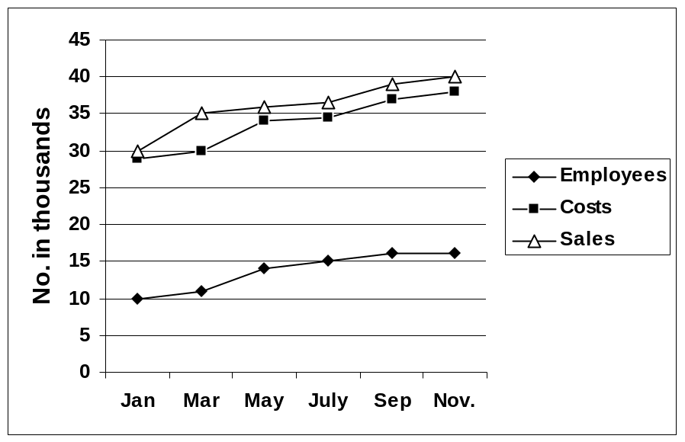DIRECTIONS for questions 36 to 38: Refer to the graph given below and answer the questions that follow.

36. Which month has the highest profit per employee?

1. September 2. July 3. January 4. March 5. None of these

37. Which month records the highest profit?

1. June 2. July 3. March 4. May 5. September

38. In which month is the percentage increase in Sales over the Sales two months before, the highest?

1. March 2. September 3. July 4. May 5. None of these
Directions for questions 39 to 41 –
U, V, X, Y and Z collected CDs of yesteryears’ melodious songs. They collected a total of 100 CDs. None of them have collected less than 10 CDs. No two among them collected the same number of CDs Also,
i. U collected the same number of CDs as V and X put together
ii. X collected 3 more CDs than the cube of an integer.
iii. The number of CDs collected by U was the square of an integer
iv. The number of CDs collected by V was either the square or the cube of an integer. v. The number of CDs collected by Y and Z are in ratio 4 : 3
39. What was the number of CDs collected by V?
a. 16 b. 25 c. 46 d. 64

40. What was the difference in the number of CDs collected by X and Y?
a. 5 b. 7 c. 9 d. 11

41. How many of the individuals collection (s) of CDs was / were prime numbers?
a. 0 b. 1 c. 2 d. 3

Directions for questions 42 – 45: Read the passage given below & answer the questions that follow
Ignorance of the cause [of the plague] augmented the sense of horror. Of the real carriers, rats and fleas, the 14th century had no suspicion, perhaps because they were so familiar. Fleas, though a common household nuisance, are not once mentioned in contemporary plague writings and rats only incidentally, although folklore commonly associated them with pestilence. The legend of the Pied Piper arose from an outbreak of 1284. The actual plague bacillus, pasturella pestis, remained undiscovered for another 500 years. Living alternately in the stomach of the flea and the bloodstream of the rat who was the flea'’ host, the bacillus in its bubonic from was transferred to humans and animals by the bite of either rat or flea.
It traveled by virtue of Rattus rattus, the small madieval black rat that lived on ships, as well as by the heavier brown or sewer rat. The phanton enemy had no name. Called the Black Death only in later recurrences, it was known during the first epidemic simply as the pestilence or Great Mortality. Reports from the East, swollen by fearful imaginings, told of strange tempests and “sheets of fire” mingled with huge hailstones that “slew almost all,” or a “vast rain of fire” that burned up men, beasts, stone, trees, villages, and cities. In another version , “foul blasts of wind” from the fires carried the infection to Europe “and now as some suspect it cometh round the seacoast.” Accurate observation in this case could not make the mental jump to ships and rats because no idea of animal- or insect- borne contagion existed. The earthquake was blamed for releasing sulfurous and foul fumes from the earth’s interior.
All these explanation had in common a factor of poisoned air, of miasmas and thick, stinking mists traced to every ‘kind of natural or imagined agency from stagnant lakes to malign conjunctions of the planets, from the hand of the Evil One to the wrath of God. Medical thinking, trapped in the theory of astral influences, stressed air as the communicator of disease, ignoring sanitation or visible carriers. The existence of two carriers confused the trail, the more so because the flea could live and travel independently of the rat for as long as month and, if infected by the particular septicemic form of the bacillus, could infect humans without re-infecting itself from the rat. The simultaneous presence of the pneumonic form of the disease, which was indeed communicated through the air, blurred the problem further. Barbara W. Tuchman. A Distant Mirror: The Calamitous 14th century.
Alfred A.Knopf.Inc.1978.pp.101-102.

42. According to the passage, which of the inferences below is most probable?
A. Medical thinking in Europe concerning cause and spread of plague had advanced beyond common observations and accounts by the common people.
B. Those familiars with legend of the pied piper arising from an outbreak of plague might reasonably be expected to have associated rats with the outbreak of plague.
C. Magical and supernatural explanations of cause and spread of plague were accorded more credibility than explanation rooted in empirical observation.
D. Because fleas were common in households, eventually the connection between fleas and the spread of infection was bound to be made.
E. During the tenure of the plague in Europe, invisible carriers were accorded more credibility as causal agents than visible carriers.

43. In this passage, the relationship between the flea and the rat most closely corresponds to the relationship between
A. minor and major vectors of the plague B. predator and prey
C. parasite and host D. real and imagined carriers
E. rat and human

44. Which of the following statements best describes the organization of this passage?
A. It presents a generalization, then lists in order of occurrence events that support that generalization.
B. It cities correct and incorrect causal explanations of plague and analyzes the bases of the incorrect explanations advanced by contemporary observers of the plague
C. It distinguishes theories of airborne contamination and theories of blood-borne contamination.
D. it alternates popular and folkloric conceptions of causation and accurate modern accounts of causation.
E. It cities contemporary plague writings, folklore, reports from the East, and current medical thinking in increasing order of accuracy.

45. This passage analyzes impediments to accurate explanations of the causes of plague in order to
A. connect natural events with outbreaks of plague
B. connect ignorance of the cause of plague with increased terror
C. explain the general disease theory of the time
D. connect plague to theories of poisoned air, tempests, rains of fire
E. discredit all explanations of the plague advanced by contemporary observers

Directions for questions 46 – 47: Choose the odd man out

46. A)Maid B)Lady C)Butler D)Girl E)Lass
47. A) Sword B) Spear C)Mace D) Gun E) Lance
Directions for questions 48 – 50: Each sentence below has been split into four parts. Indicate the part with a error. Mark (e) if there is no error. (You can ignore the commas, question mark..etc?)

48. a. If he would b. have come c. I will d. gone.

49. a. We might admire a b. bad man though c. we cannot admire a d. week one.

50. a. I called her b. but she c. did not d. came

